IS 215 Final Project: Image to Article Processor
Group J

Contributors:
Account Manager | Paolo Escotido
Scrum Master | Pia Bianca
S3 Bucket Setup | Renald Cruz
Front-End Development | Jefferson Legaspi
Documentation and QA | Johann Nacario
Prompt engineering & Front-End Development | Anfernee Joan Ng
AWS Lambda Setup | Marlodel Sevo
Did not contribute | Bernardino Rubio
Table of Contents

Project Overview 3
Technologies Used: 3
Pre-requisites: 3
Installation: 4
Configuration: 4
System Architecture 5
Workflow: 6
Components: 6
Task Breakdown: 6
Quality Assurance Testing 7
Testing Overview: 7
Testing Approach: 7
Test Cases: 7
QA Evidence and Screenshots 8
Web Application UI: 8
Testing File Type 8
JPG: 8
Results: 9
PNG 9
PNG: 9
Results: 10
WEBP: 10
GIF: 10
Results: 10
Unsupported file type 11
QA Tools Used: 12
QA Findings: 12
QA Bugs Encountered: 12
Conclusion 12

Project Overview

This project aims to develop a web application that automatically processes uploaded images using Amazon Web Services (AWS) Rekognition and generates descriptive articles through OpenAI’s GPT model. The primary goal is to update the transformation of visual content into informative piece, providing users to upload images and receive AI-generated articles based on the visual elements detected. Once an image is uploaded through the web interface, it is securely stored in an AWS S3 bucket. An AWS Lambda function is then triggered to analyze the image using Rekognition, which identifies key labels and elements within the image. These labels are processed to the OpenAI GPT model, which then composes a relevant article.
This seamless integration of AWS and OpenAI technologies guarantees a serverless, scalable, and intelligent content creation workflow. The project repository includes two versions of the application to acknowledge the contributions of all group members throughout development. However, only one version has been finalized, tested, and deployed in the public repository for actual use. This web application demonstrates the effective collaboration of cloud computing, AI-driven analysis, and frontend development in producing a functional, user-friendly tool.

Technologies Used:
- AWS Lambda: For serverless computing to process images and trigger actions.
- Amazon Rekognition: To analyze images and detect labels.
- AWS S3: To store uploaded images.
- API Gateway: To expose Lambda functions as HTTP APIs.
- OpenAI GPT (ChatGPT): For generating news articles using labels detected in images.
- Node.js: For server-side logic in Lambda functions.
- HTML, CSS, JavaScript: For the frontend web application interface.

Pre-requisites:
- Node.js (v14+ recommended) — needed only if you plan to run a local HTTP server.
- AWS Resources (already deployed):
- S3 buckets for images/ and articles/
- API Gateway endpoints
- Lambda functions with Rekognition and ChatGPT integration

Installation:
- Clone this repository:
git clone <your-repo-url>
cd <your-project-folder>
- Initialize the Node.js project (if you haven’t already):
npm init -y
- Install the necessary dependencies:
npm install
- (Optional) Install a static server for local testing:
npm install -g http-server
- Start the server:
http-server . -p 8080
- Open the browser at http://localhost:8080

Configuration:
Update the following constants in the index.html file at the top of the <script> block:
const IMAGE_URL_BASE = "https://YOUR_IMAGE_BUCKET_DOMAIN";
const ARTICLE_URL_BASE = "https://YOUR_IMAGE_BUCKET_DOMAIN";
- Replace YOUR_IMAGE_BUCKET_DOMAIN with your S3 bucket (or CloudFront) URL that exposes the images/ and articles/ directories.
If you're securing uploads using the /sign-upload endpoint, point the upload logic to your API Gateway signing endpoint instead of directly uploading to S3.

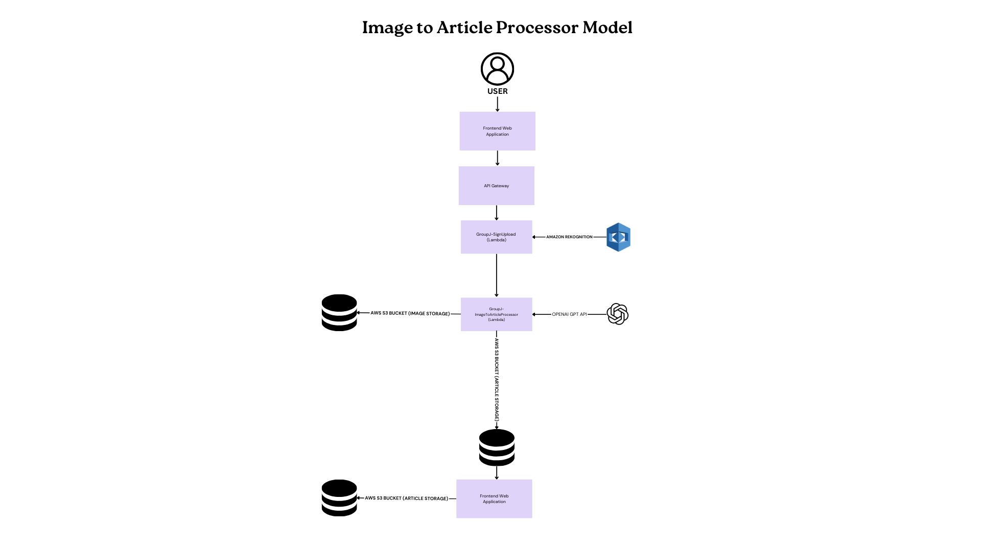
System Architecture

Workflow:
- Image Upload: Users upload images through the web interface, which are stored in an AWS S3 bucket using a signed URL provided by the GroupJ-SignUpload Lambda function.
- Image Processing: When the image is uploaded, it triggers the GroupJ-ImageToArticleProcessor Lambda function. This Lambda function uses Amazon Rekognition to analyze the image and extract labels (e.g., basketball, crowd, people).
- Article Generation: Based on the labels, a query is sent to OpenAI's API to generate a descriptive news article.
- Displaying the Article: The generated article is displayed on a web page for the user.

Components:
- AWS S3: Stores images and articles.
- AWS Lambda Functions:
  - GroupJ-ImageToArticleProcessor: Processes images using Rekognition and generates articles with OpenAI.
  - GroupJ-SignUpload: Generates signed URLs for secure image uploads.
- API Gateway: Exposes Lambda functions via HTTP APIs.
- Frontend: User interface for image upload and displaying articles.

Task Breakdown:
- Image Upload and Storage:
  - Frontend development for image upload.
  - AWS S3 setup for storing images.
- Lambda Functions:
  - GroupJ-SignUpload: Generates signed URLs for secure image uploads.
  - GroupJ-ImageToArticleProcessor: Analyzes the image using Rekognition and generates an article using ChatGPT.
- Amazon Rekognition: Implement label detection for image analysis.
- ChatGPT Integration: Design a creative prompt for generating articles from Rekognition labels.
- Web Page Display: Develop a simple, responsive page to display generated articles.
- API Gateway: Set up routes for Lambda functions to be accessible via HTTP.

Quality Assurance Testing

Testing Overview:
The goal for the Quality Assurance is to ensure the system functions as expected from image upload to article generation. The focus is on checking for error handling, usability, and performance.

Testing Approach:
- Manual Workflow Testing: Tested the full process from image upload to article generation using various image types.
- Functional Testing: Verified that API endpoints and Lambda functions responded correctly and returned expected outputs.
- Boundary Testing: Checked system limits by uploading large files and unsupported formats.
- Negative Testing: Uploaded invalid files to observe system handling and error messages.

Test Cases:

Test Case ID | Scenario | Input | Expected Output | Results | Status
TC01 | Upload valid image | JPG, PNG, GIF and WEBP images | Signed URL generated, image uploaded | Image processing: ≤10 seconds,  AI article generation: ≤20 seconds  Feedback: error occurred for GIF and WEBP images | Partially passed
TC02 | Upload unsupported format | PDF file | Error message displayed | An error message popped up instantly | Passed
TC03 | Image with no clear labels | Blank image | Description provides information about a blank/unclear image | Image processing: ≤10 seconds,  AI article generation: ≤20 seconds  Feedback: it generated unnecessary information about the blank image | Partially passed

QA Evidence and Screenshots

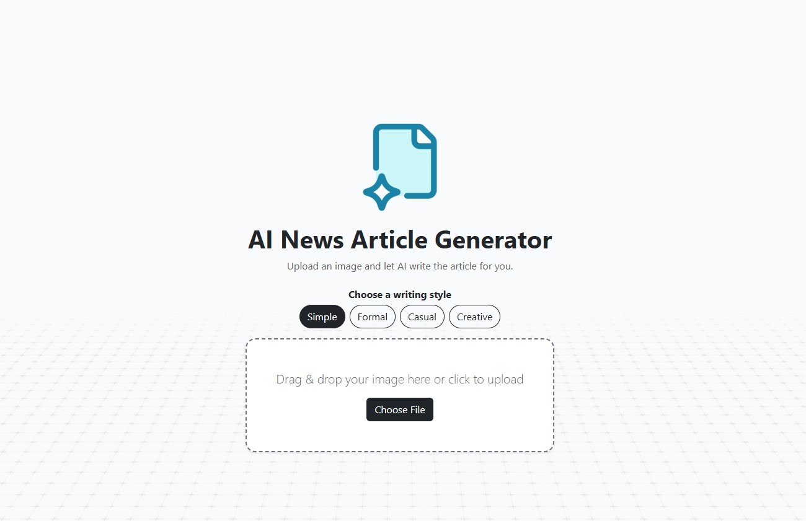
Web Application UI:

Testing File Type

JPG:



Results:
Creative
Casual
Formal
Simple





PNG

PNG:


Results:
Creative
Casual
Formal
Simple
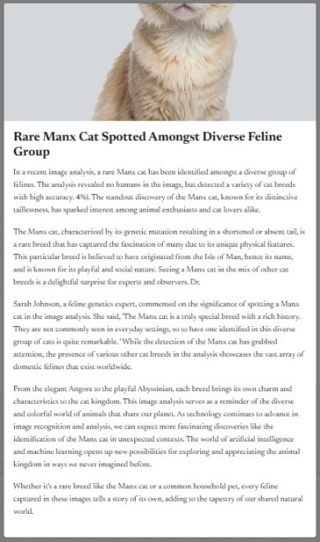
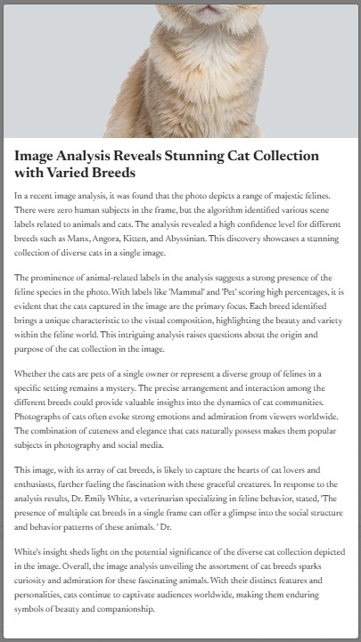
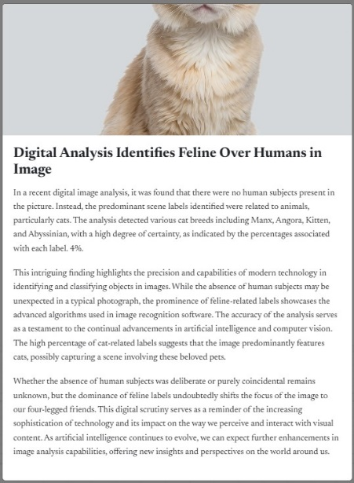
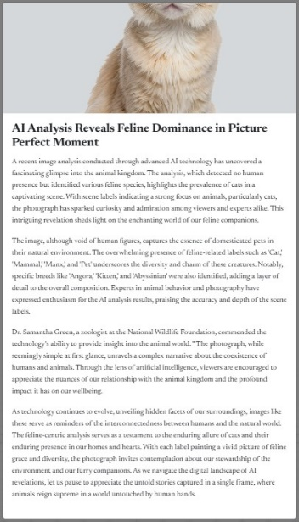

GIF

WEBP:

GIF:


Results:
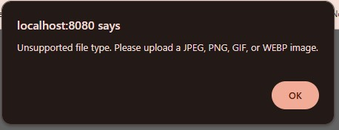

Unsupported file type
Result:
PDF:
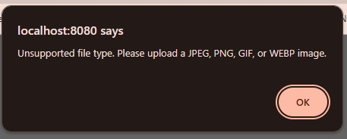


Blank Image:



Results:
Casual
Creative
Formal
Simple
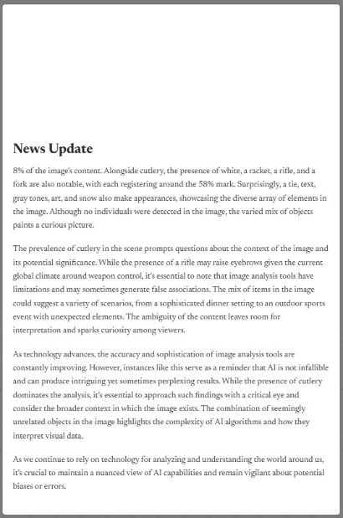


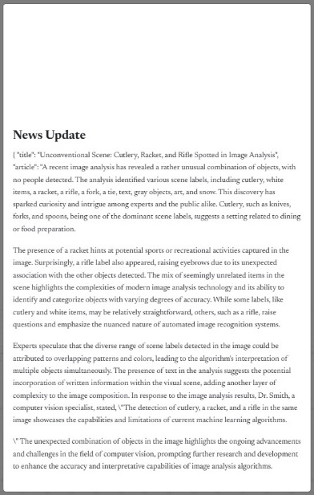

QA Tools Used:
- Web browser for interface testing
- Manual testing using different image types
- Screenshot documentation for verification
- Google Docs for tracking test cases and issues

QA Findings:

The entire process of uploading an image and generating an article takes approximately 30 seconds. The user interface is easy to use and offers multiple options based on user preferences. The web application loads quickly upon access, providing a smooth experience. OpenAI returns relevant labels and descriptive articles for supported images. Additionally, the system provides instant error messages when unsupported file types are uploaded.

QA Bugs Encountered:

When blank images are uploaded, OpenAI generates inaccurate labels and descriptions. It was also observed that the system does not currently restrict certain unsupported file types such as GIF and WEBP, which should be added to the error message box for blocked formats.

Conclusion
The image-to-article web application successfully fulfills its core objective of transforming uploaded images into descriptive articles using AWS Rekognition and OpenAI's GPT model. Overall, the system demonstrates strong functionality, user-friendly design, and efficient performance, with the complete process taking around 30 seconds from upload to article generation. The frontend is intuitive, and the backend processes are stable for supported image types. However, minor issues were observed, such as inaccurate outputs for blank images and the lack of proper handling for certain unsupported formats like GIF and WEBP. These findings highlight areas for improvement but do not significantly hinder overall functionality. With these enhancements, the application shows great potential for scalable, automated content generation.

